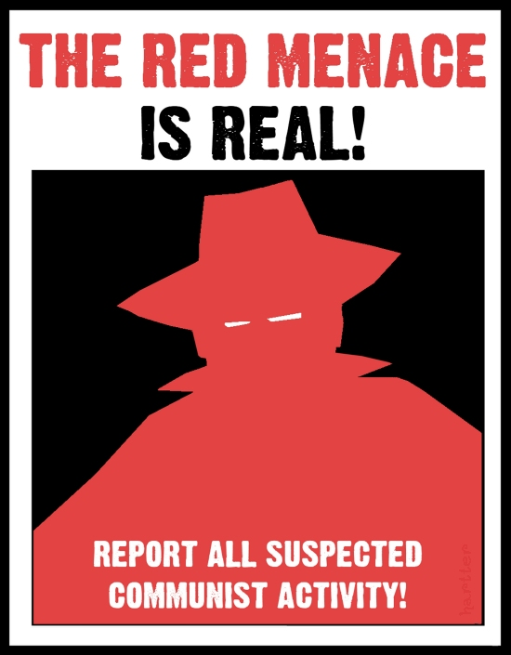

Lesson Plan
Red Light, Green Light: 1950s Red Scare in America
Samantha Strunk-Hintz
April, 2012

Lesson Plan
Red Light, Green Light: 1950s Red Scare in America
Samantha Strunk-Hintz, April 2012

Grade Level: 8th Grade

Overview: This lesson could be used in a series of lessons concerning the Cold War, its effect on the United States, and the various roles the United States played in this global issue. The activity is designed to give students a more personal idea of what it meant to live through the Red Scare during the 1950s, helping them understand why people did what they did by doing a small reenactment rather than trying to understand motives through reading a textbook. The activity itself should take anywhere from 5-10 minutes, with a discussion to follow.

The question that students should be thinking about is: How much are historical events affected by the context in which they happen? Students may have previously had a difficult time imagining a situation in which they would accuse a person of being a communist spy without any apparent evidence, a concept known as McCarthyism. Many forget the context that these people in history were acting in, assuming that they themselves would never accuse someone without evidence, especially not their own friends or people they know. This activity puts them in a situation where they have to think about strategy and who they can really trust, helping them to think about the context of the Red Scare during the 1950s in the United States and how it shaped people’s decisions and behaviors.

Arizona State and National Standards

Arizona 8th Grade Content Standards:

Arizona Concept 1: Research Skills for History:
PO 7. Analyze the cause and effect relationships between and among individuals and/or historical events.

Arizona Concept 9: Postwar United States:
PO 2. Describe the impact of the Cold War on the United States:
- McCarthyism

NCSS Thematic Standards:

Culture and Cultural Diversity:
-Learners should be able to interpret patterns of behavior as reflecting values and attitudes, which contribute to or pose obstacles to cross-cultural understanding.

Individual Development and Identity:
-Learners should be able to compare and evaluate the impact of stereotyping, conformity, acts of altruism, discrimination, and other behaviors on individuals and groups.

Historical Thinking Standards

Historical Thinking Standard 3: Historical Analysis and Interpretation:
-Students should consider multiple perspectives of various peoples in the past by demonstrating their differing motives, beliefs, interests, hopes, and fears.

Historical Thinking Standard 5: Historical Issues:
-Students should evaluate the implementation of a decision by analyzing the interests it served; estimating the position, power, and priority of each player involved; assessing the ethical dimensions of the decision; and evaluating its costs and benefits from a variety of perspectives.

Materials: Small piece of paper for each student in the class, with either the word ‘Green’ or ‘Red’ written on one side. There should be more Greens than Reds, with approximately 2/3 or higher being Green and the rest being Red.

Instruction:
- Each student should receive a piece of paper that has ‘Green’ or ‘Red’ written on one side. After reading the word on their piece of paper they are to put it away where no one can see it, either in their backpack or in their pocket if they have one. The paper should not be shown to anyone else in the class. A ‘Green’ paper symbolizes a normal individual, while a ‘Red’ paper symbolizes someone who is a Communist.
- After every student has received their piece of paper, they will all get out of their desks and form groups with the other students. Because the students are not allowed to show their piece of paper to anyone or tell anyone what their piece of paper said, they will have to strategize and decide who they are willing to trust to be in their group.
- The objective of the activity for those who received a ‘Green’ paper is to form the largest group that they can with only those who also got a ‘Green’ paper. The objective for the few ‘Red’ paper people is to infiltrate a group and be the only ‘Red’ in that group when time is up.
- When time is up (5-10 minutes depending on class size), certain students will be awarded points depending on the composition of the groups. If a group only contains people with a ‘Green’ paper, each student in that group will receive a point. However, if a group has a ‘Red’ person in it then the ‘Red’ student will get a point for each ‘Green’ person in the group. If there is more than one ‘Red’ student then they will split up the points.

Discussion Questions:

-How did you initially decide who to form a group with? Were you automatically drawn to your friends in the class, or did you wait to see what others were doing before you made a decision?

-Did you notice any leaders emerging in your groups? If so, who were they? Did they influence everyone else’s ideas about who should/shouldn’t join the group? What did they say to make you trust them?

-At any point during this activity, did you suspect someone in your group of being a ‘Red’? If so, why did you suspect them? Was it because you didn’t know them as well as everyone else or because of something they said/did? If you did suspect someone, were you right?

-Did you suspect anyone of being a ‘Red’ that turned out to actually be a ‘Green’? If so, how did you feel after finding out that you were wrong about this person?

-Just like McCarthyism in the 1950s, none of you had any concrete evidence on whether or not someone was a Communist spy. Why do you think people during that time accused others of being spies when they had no evidence to back up their suspicions?

-Now that you have been in a situation similar to what some people back then might have gone through, what do you think you would have done had you been in their place? Did this activity help you understand what these people might have been thinking?

**A similar version of this lesson was taught in an AP United States History Class at Flagstaff High School

