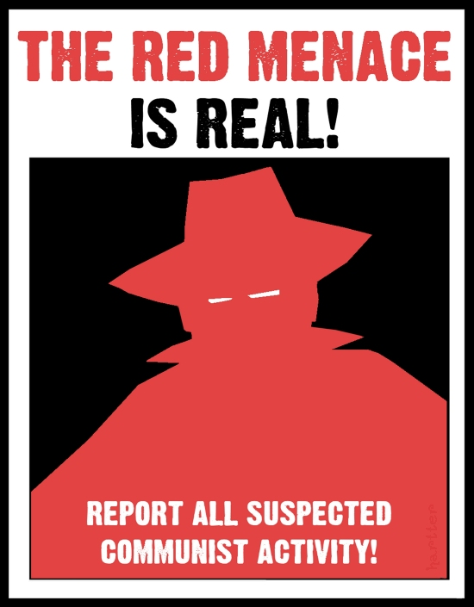

Lesson Plan
Red Light, Green Light: 1950s Red Scare in America
Samantha Strunk-Hintz
16 November 2012

Grade Level: 8th Grade

Time: 2 days (approx. 85 minutes)

Overview: This lesson, while standalone in this particular format could easily be used in a unit concerning the Cold War, its effects on the United States, and the various roles the United States played in this global issue. The activities included in this lesson are designed to give students a more personal idea of what it meant to live through the Red Scare during the 1950s, helping them to understand why people did what they did through means other than a textbook.

Rationale: The purpose of this lesson is to evaluate the political, social, and cultural impact of McCarthyism in America, and how times of intense fear and tension can result in a restriction of civil liberties in the name of national security.

Standards

Arizona State Social Studies Standards:

Strand 1: American History
Concept 9: Postwar United States:
PO 2. Describe the impact of the Cold War on the United States
a. McCarthyism

Arizona State Science Standards:

Strand 1: Inquiry Process
Concept 3: Analysis and Conclusions
PO 5. Explain how evidence supports the validity and reliability of a conclusion

Arizona State Writing Standards:

Strand 3: Writing Applications
Concept 4: Persuasive
PO 1. Write persuasive text (e.g. essay, paragraph, written communications) that:
b. supports arguments with detailed evidence
c. includes persuasive techniques

Essential Questions

-Why was Soviet espionage such an important issue in the late 1940s and early 1950s?
-What constitutes an “un-American” activity?
-What impact did Joseph McCarthy have on American anti-communism?
-Why were Americans so fearful of communism?
-What was the real nature of the Communist threat during the Cold War?

Language Objectives

SWBAT define the vocabulary terms presented in this lesson
SWBAT construct full sentences and develop an argument
SWBAT understand the terms and use them appropriately in discussion

Learning Outcomes

- Students will relate to the fears and suspicions that arose during the McCarthy era by using role play. They will reflect on the effects of McCarthyism and its relation to peoples’ personal lives. Through role playing and discussion they will reflect on their findings and answer prompts/questions.
-Students will brainstorm on the impacts of the Cold War, specifically McCarthyism and the fear it generated, as evidence through participating in a cooperative class activity.
2. Students will use technology, research, and critical thinking skills to exemplify their understanding of the events that took place. Students will research a specific event that relates to the discussion.
-Students will research enduring questions identified at the beginning of the lesson and explain what evidence presented in the event led to its eventual conclusion through class discussion.
3. Students will discuss specific events that represent McCarthyism in the United States. They will evaluate arguments made during these events and reflect on their outcomes.
-Students will employ persuasive techniques in relation to specific questions and events by writing a short persuasive essay.
4. Students will actively engage questions of civil liberties and the appropriateness of governments suspending these inherent rights.

Assessment

**Persuasive Essay
After completing the lesson, students should be able to write a brief (1-2 paragraph) essays answering the following: Why were the Rosenbergs convicted of espionage? Do you believe that verdict was just? Why or why not? Assuming the Rosenbergs were guilty, do you think they deserved the death penalty? Write a 1-2 paragraphs making an argument for why or why not you agree with the Rosenberg verdict.

Criteria | 4 | 3 | 2 | 1
The Claim | Makes claim & explains why it is controversial | Makes claim but doesn’t elaborate | Claim is buried, confused, and/or unclear | No clear claim or thesis present
Support | Gives clear & accurate reasons/support | Support present by important reasons may be absent | A few weak reasons are present but may be irrelevant or confusing | No convincing reasons in support of claim are present
Arguments | Discusses arguments that oppose their claim | Discusses arguments but doesn’t explain how their claim is still valid | Reasons against the claim present but not discussed | Doesn’t acknowledge or discuss reasons against their claim
Organization | Writing has compelling opening, middle, and end | Writing has beginning, middle, and end but doesn’t flow | Writing is organized but sometimes gets off topic | Writing has no clear organization and/or aim
Voice/Tone | Sounds like they care; clearly shows thoughts and feelings | Tone is decent but voice is weak | Writing is bland and no voice is present | Writing is too informal and sounds like they don’t care
Word Choice | Words are interesting, varied, and well thought out | Made routine word choices | Words are uninspired and often dull | Repeats words over and over; some words may be confusing to reader
Sentence Fluency | Sentences are clear, complete, and of varying lengths | Sentences are well-constructed but basic | Sentences are sometimes awkward and/or contain run-ons and fragments | Many run-ons and fragments present; phrasings make essay hard to read
Conventions | Uses correct grammar, spelling, and punctuation | Generally uses correct conventions; a few errors | Enough errors present that reader may be distracted | Numerous errors make paper hard to read
(Students may be allowed to go to Computer lab to type their essays if they prefer)

**Discussion Checklist

1. Engagement
-Students will show that they are paying attention with their body language
-Students will listen to their classmates’ comments with an open mind and think carefully about how they support their opinions
-When not talking, students will exhibit appropriate behavior such as making eye contact with the speaker, smiling, nodding, etc.
2. Interaction
-Students will contribute their own appropriate experiences and opinions when they fit naturally into the flow of the discussion
-Students build on others’ comments and make comments that enhance preceding comments by questioning, summarizing, paraphrasing, elaborating, etc.
3. Collaboration
-Students should enthusiastically contribute to the discussion without talking out of turn or talking too much, preventing other students from contributing
-Students will be respectful of their classmates’ opinions, even if they disagree, and will respond respectfully when addressing their peers
4. Reflection
-Students should reflect on their participation and set goals for how they could be a better participant in the future

Background Knowledge

Students should have basic knowledge of the Russian Revolution to understand the source of communism, and should have basic understanding of WWII and its effects on the United States. This lesson also assumes that students have been taught the basics of developing an argument and writing short essays.

The Cold War was a unique time in American History. Americans feared Communism for at least 45 years and employed a variety of methods to eliminate it, or at least contain it. While the nation had just come out of a terrible war, and was prepared to do so again if necessary, no actual fighting took place because the Cold War was a war of ideologies instead of a physical war. Students today were born years after the collapse of the Soviet Union and the Berlin Wall and so often find it hard to understand and connect with the intense panic that transformed the lives many people in the United States during that time period. This lesson will allow students to look at that time period through multiple perspectives and become more aware of how Americans may have felt during that era and how those feelings caused them to react.

A series of events that took place shortly after WWII – China becoming a communist power, Moscow successfully testing an atomic bomb, and a war in Korea – led to the arrest, and in many cases prosecution, of a number of Soviet spies in the United States. Many people thought that one of the main reasons these events were allowed to happen was because there were disloyal Americans at home who were secretly traitorous spies. Americans started to question what it was exactly that constituted disloyalty, and the terms Alger Hiss, Whittaker Chambers, House of Un-American Activities Committee (HUAAC), Julius and Ethel Rosenberg, and Joseph McCarthy were commonly heard in households across the country. Students will learn about specific events from this time period, namely the case of Julius and Ethel Rosenberg, and consider how much of the anticommunist sentiment was justified and how much was an overreaction.

Anticipatory Set

To begin the lesson, the teacher will show a two minute YouTube clip of “Casino Royale” being played to the song of “Secret Agent Man” (http://www.youtube.com/watch?v=j09_gdNBuTY). This will hook students by providing them with a technological visual and getting them in the mood to talk about spies. Movies like Skyfall, Casino Royale, the Bourne Trilogy, Mission Impossible, and Inception involve exciting action-packed plots that have to do with spying and deception and are a big part of popular culture today.

In order to determine prior knowledge about the 1950s and the Cold War, and to get students starting to think about what they are going to learn about in this lesson, have students individually brainstorm all of the people, places, and ideas that they know about the time period in a KWL chart. Then in groups of three or four have the students share the items that they wrote down and add any they didn’t have to their list. Afterwards, have students participate in a class-wide discussion about all of the different things they came up with.

-What was going on in the 1950s, after WWII?
-What is Communism?
-Why were Americans afraid of Communism?
-Why would it be bad to find out that there were Russian spies in America?

Students could either create their own KWL chart in their notebooks, or use the sheet provided by the teacher. Any students who have their own electronic devices for assistance may use those as well to organize their thoughts.

Vocabulary
-Democracy: A form of government in which all eligible citizens have an equal say in the decision that affect their lives

-Communism: A system where the government owns everything and distributes it as it decides is fair and is in charge of regulating the economy

-McCarthyism: The practice of making accusations of disloyalty, subversion, or treason without proper regard for evidence.

-House Un-American Activities Committee: An investigative committee of the United States House of Representatives created in 1945 to look into suspicious activities

-Joseph McCarthy: American senator in the 1950s who became famous after making sensational but unproved charges of Communist espionage in high government circles

-Julius and Ethel Rosenberg: American communist couple who were convicted and executed in 1953 for supposed conspiracy to commit espionage during a time of war

-Hollywood Ten: 10 producers, directors, and screenwriters who appeared before the HUAAC in 1947 refusing to answer questions about their possible affiliation with Communists, and were blacklisted afterwards by most Hollywood studios

-Cold War: State of conflict between the United States and Russia that did not involve direct military action but was pursued through economic and political action, propaganda, and acts of espionage

-Espionage: Form of spying where a group or individual obtains information that is considered secret or confidential without the permission of whoever has the information; punishable by law

Procedures:

Introduction:

1. Introduce the topic to the class: Red Scare in America. Present the objectives of the lesson to the students. Ask the students what they think/remember about Communism and the Cold War. Call on several students to answer what those terms mean to them.

2. After several students have offered up definitions and/or ideas, project the definitions of Communism, Democracy, and Cold War on the board.

3. Now that the student’s have been presented with the topic and the objectives of the lesson, play the YouTube video. Before playing the video, ask students to start thinking about what they know about what the Cold War was like in the United States.

4. After the video, have students individually write down what they know, think they know, and want to learn about what was going on in the 1950s, and what kinds of things they know about Communism during this time period. Allowing them 3-5 minutes for this individual brainstorming, students will then be asked to get together in groups of three or four to discuss what they wrote down.

Discussion:

1. Following the group discussions, a class discussion will start. The teacher will prompt the students to share anything they wrote down concerning:
- What was going on in the 1950s, after WWII?
- What is Communism?
- Why were Americans afraid of Communism?
- Why would it be bad to find out that there were Russian spies in America?

2. It is important to make the students feel safe sharing what they wrote down, clarifying that at this point in the lesson there are no right or wrong answers, and that all of the students are respectful.

3. When appropriate, reference the YouTube video to enhance the discussion. This will help students who are visual learners to stay included and help the other students remember what they felt/were thinking about when they saw the video.

Activity – Red Light Green Light:

Materials: Small slip of paper for each student in the class, with either a Green dot or a Red dot on it. There should be more Greens than Reds, with approximately 2/3 or higher being Green and the rest being Red.

1. Inform students that they will be transported back to 1949, a time of suspicion of neighbors, friends, and co-workers. They are going to be everyday people in 1949; however, amongst them there are enemy spies.

2. Each student will receive a slip of paper with either a Green or Red dot on it. After glancing at their slip of paper to see what color they are, they are to put the slip of paper where no one else can see it, such as in their pocket if they have one. Inform the students that under no circumstances may they show their paper to anyone. Tell them that a Green dot symbolizes an average American citizen while a Red dot symbolizes a communist spy.

3. After every student has received their slip of paper and put it away in a safe place where no one else will see it, they will all get out of their desks. The goal is to form the largest group of “friends” without allowing someone they suspect to be a communist to join them.

4. Everyone may ask questions and they may be asked questions, but it is their call as to whether or not they tell the truth or believe the speaker (Remember, the person you are speaking to might be a spy!).

5. The largest group without a member with a red dot on their slip of paper wins. Any person who holds a red dot paper and manages to infiltrate a group wins.

6. The activity should take 10-15 minutes but be flexible with time depending on the class size and how well you judge the activity to be going. When time is up, bring students back to their desks for a discussion.

**Note: You may want to project a slide on the board that has a list of the instructions on it, as some students may not be able to remember everything and need a visual.

Discussion:

1. Initiate a class discussion asking the following questions, allowing a few minutes per each question for student responses:

-How did you initially decide who to form a group with? Were you automatically drawn to your friends in class, or did you wait to see what others were doing before you made your decision?

-Did you notice any leaders emerging in your groups? If so, who were they? Did they influence everyone else’s ideas about who should/shouldn’t join the group? What did they say to make you trust them?

-At any point during this activity, did you suspect someone in your group of being a “Red”? If so, why did you suspect them? Was it because you didn’t know them as well as everyone else or because of something they said/did? If you did suspect someone, were you correct in your suspicions?

-Did you suspect anyone of being a “Red” that turned out to actually be a “Green”? If so, how did you feel after finding out that you were wrong about this person?

2. After the discussion, explain that there was a man named Joseph McCarthy who did things similar to this activity in America during the 1950s. He accused various people of being Communist spies and set off a wave of hysteria across our country.

3. On the board, write out the other vocabulary terms that are crucial to this lesson: Joseph McCarthy, McCarthyism, Espionage, House Un-American Activities Committee, and Hollywood Ten. Read all of the definitions aloud for students as you are writing them out, as some students do better when they are able to see and hear definitions. This also helps out any students that may have vision impairments.

4. After making sure that all of the students have written down the vocabulary terms, review them with students to make sure they understand each one and how it relates to this time period. Then ask students to come up with ideas of things they believe might be considered “un-American.” Allow several students to share, and then tell them that they will want to keep these ideas in mind as they will be important to think about in the next part of the lesson.

Research:

1. Students will now go to the computer lab to conduct research on a specific event that happened during the McCarthy era: The Rosenberg Trial.

2. Once all students are seated at a computer, the teacher will do a short PowerPoint presentation giving some basic background information on the Rosenberg Trial.

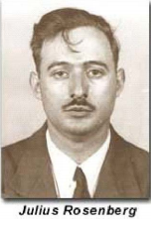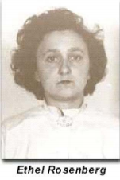

In the summer of 1949, the FBI received information that the secret on how to construct the atom bomb had been stolen and given over to the Soviet Union. The theft was investigated and first conspirator identified was Emil Julius Klaus Fuchs – a British atomic scientist who had been born in Germany. He was arrested in February of 1950, and soon after admitted his involvement in the Soviet atomic espionage. Although he did not give up the identity of his contact/s in America, the FBI was able to use extensive investigation methods to identify Harry Gold who was a chemist living in Philadelphia.

After being interrogated, Harry Gold also confessed to being involved in the espionage activity. Through Gold’s confession, the FBI was also able to uncover the name David Greenglass, a U.S. Army man who had been assigned to the atomic lab in New Mexico. Harry Gold told the FBI that he had picked up material from Greenglass in 1945 after being given instructions from his Soviet “handler.” It was David Greenglass and his wife Ruth, and their admissions of espionage, which led to the official identification of Julius and Ethel Rosenberg. David Greenglass was Ethel’s brother.

The Rosenberg case took place in New York City, but it was closely followed throughout the entire country through newspapers and radio reports. This became not only a federal case, but a trial of public opinion as well, and the Rosenbergs became America’s most treacherous villains. What isn’t clear in the evidence however, is the reality of that label. The trial, conviction, and death sentence that followed divided the nation and kept current the issue of Soviet espionage in America for years to come.

3. The teacher, following the presentation, will then have students do online research in order to compile a list of evidence that was presented in the Rosenberg case. Discuss with students that even though Julius Rosenberg was thought be guilty in every sense, his wife was not. Have them look for specific evidence that was used to prove both his and her guilt in the case.

4. Teacher will give students a list of certain websites that will be helpful for gathering evidence:

http://law2.umkc.edu/faculty/projects/ftrials/rosenb/rosenb.htm

http://www.history.com/this-day-in-history/the-rosenberg-trial-begins

http://www.fbi.gov/about-us/history/famous-cases/the-atom-spy-case

5. Students may use other websites that they find, however the teacher should encourage them not to use Wikipedia

6. The teacher should allow approximately 20 minutes for research, meanwhile walking among the students and helping them if the need arises. Students may work together to make their lists of all the evidence they find.

Reflective/Persuasive Essays:

1. After the students compile their lists of evidence from online research, they will work individually to write a short (1-2) paragraph essay about their findings. The essay will work to answer these questions:

- Why were the Rosenbergs convicted of espionage?
- Do you believe that verdict was just? Why or why not?
- Assuming the Rosenbergs were guilty, do you think they deserved the death penalty?

2. Instruct students to write 1-2 paragraphs making an argument for why or why not they agree with the Rosenberg verdict.

3. Allow the rest of the time left for the students to write their essays. After covering so much content and this serious of a topic, it is important for them to reflect on all of the things they have done/heard during the lesson and how they feel about it. Ideally they should have 20-30 minutes to write their essays, depending on how well the rest of the lesson went.

4. While they are not being graded on grammar as much as they are for content and their ability to develop a strong argument, stress to the students that they should try their best to write in good full sentences with correct grammar.

Materials:

-Green/Red dot slips of paper (one for each member of the class)
-White board
-Projector
-Internet connection
-PowerPoint presentation on the Rosenberg case
-KWL Chart
-YouTube video
-Computer lab
-Flow Chart for compiling evidence

Any additional materials could be added or replaced to further incorporate universal design in this lesson. Class discussions can be modified depending on class size and diversity, and instead of a whole class discussion the teacher could write down the prompts beforehand and have students do work in small groups. This would especially be necessary if a majority of the class is intimidated by contributing to large scale discussions. However, the presentations and the anticipatory set would still be given to the whole class and then the students could break into small groups if so desired.

The research can also be modified. As mentioned in the procedures, students could work together instead of individually on researching and compiling a list of evidence pertaining to the Rosenberg case.

Also mentioned earlier in the lesson plan, students could choose to type their essays instead of handwriting them if they feel that would give them a greater chance of success. Visual drawings would not be refused, however the student would have to make a strong argument for why they would be more successful drawing a persuasive picture than writing/typing a short essay.

Statement on Universal Design:

By presenting information in a variety of different ways – YouTube videos, online computer research, PowerPoint presentation, fun activity, small group discussions and whole class discussions – I have allowed for students of all types of learning abilities to participate and have the chance to demonstrate at least one of their academic strengths. Whether students are good at oral communication, physical participation, research, writing, etc. they are given multiple opportunities to participate and excel. Doing so many different types of activities in this lesson gives students a chance to work both as a part of a team and as an individual, giving them an chance to modify learning as necessary.

Weaving together different types of technology as well as traditional methods of instruction helps make the lesson accessible to all types of students, whether or not they have learning impairments, disabilities, language barriers, etc. Participation by all students is encouraged in multiple ways, with time in between each activity/discussion for those who aren’t as comfortable being so involved to work individually. Each part of the lesson is easily open to modifications, depending on the levels of each student as an individual and levels of the class as a whole. The objectives and essential questions are made clear at the beginning of the lesson so as to give structure to students that need it, and there is a good flow to the lesson that gives students knowledge about what they are supposed to be doing at all times.

Technology:

Technology is used throughout the entire lesson through various presentations and the research portion done in the computer lab. Since technology is such a big part of popular culture today and resonates well with almost every student, it is important to find different ways to incorporate it in the classroom. It is also important in that technology can provide alternative ways of learning for particular students who have been proven to be unsuccessful with the traditional ways of presenting and receiving information.

Name ______________________________________ Date___________________________

KWL Chart

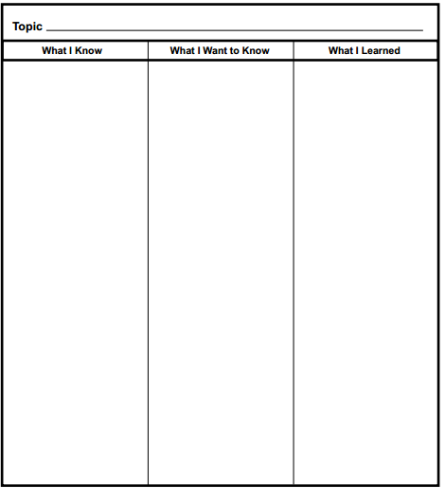

Name_____________________________________ Date____________________________

Flow Chart

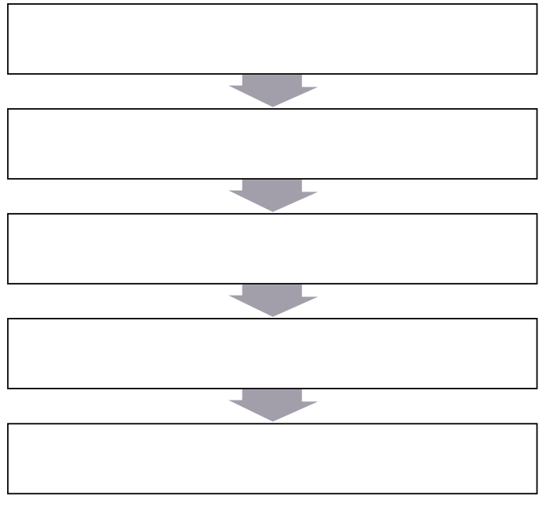
Evidence:
Evidence:
Evidence:
Evidence:
Evidence:

